**Assignment No.2**

**Prof. Anil Rajendra Chinchawade**

**College Name: N. K. Orchid College of Engineering and Technology, Solapur.**

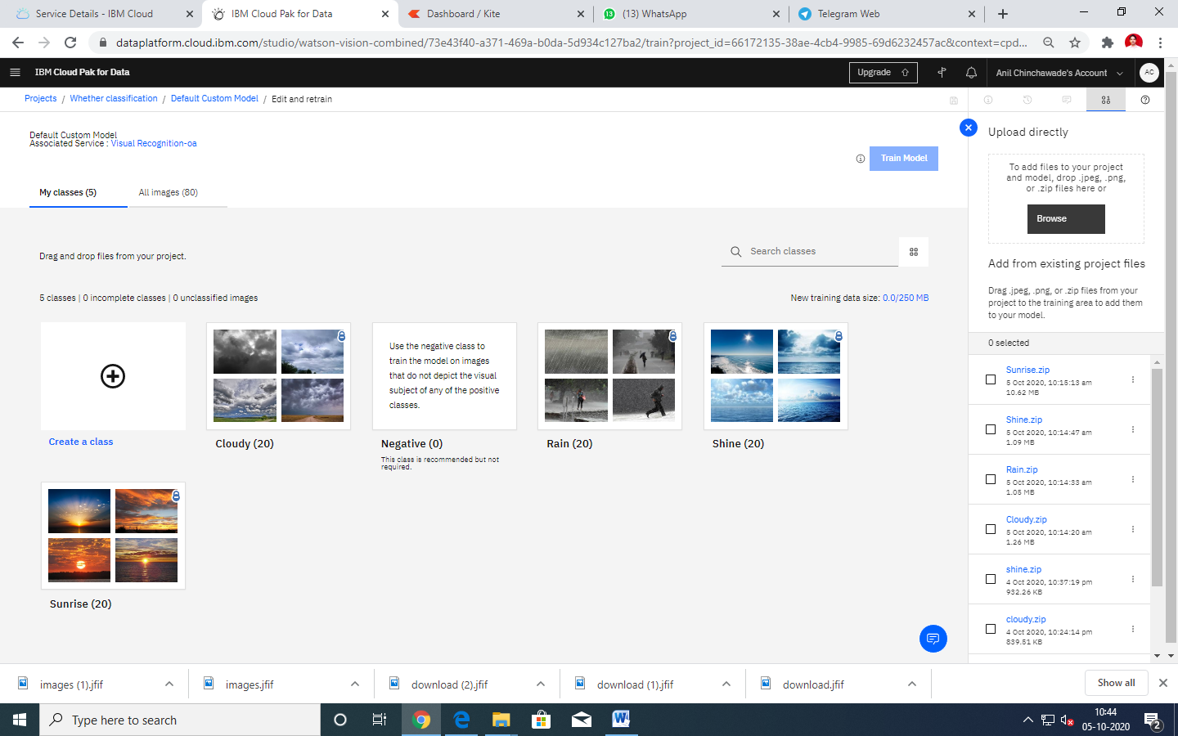

**FIG 1: Data Set Used**

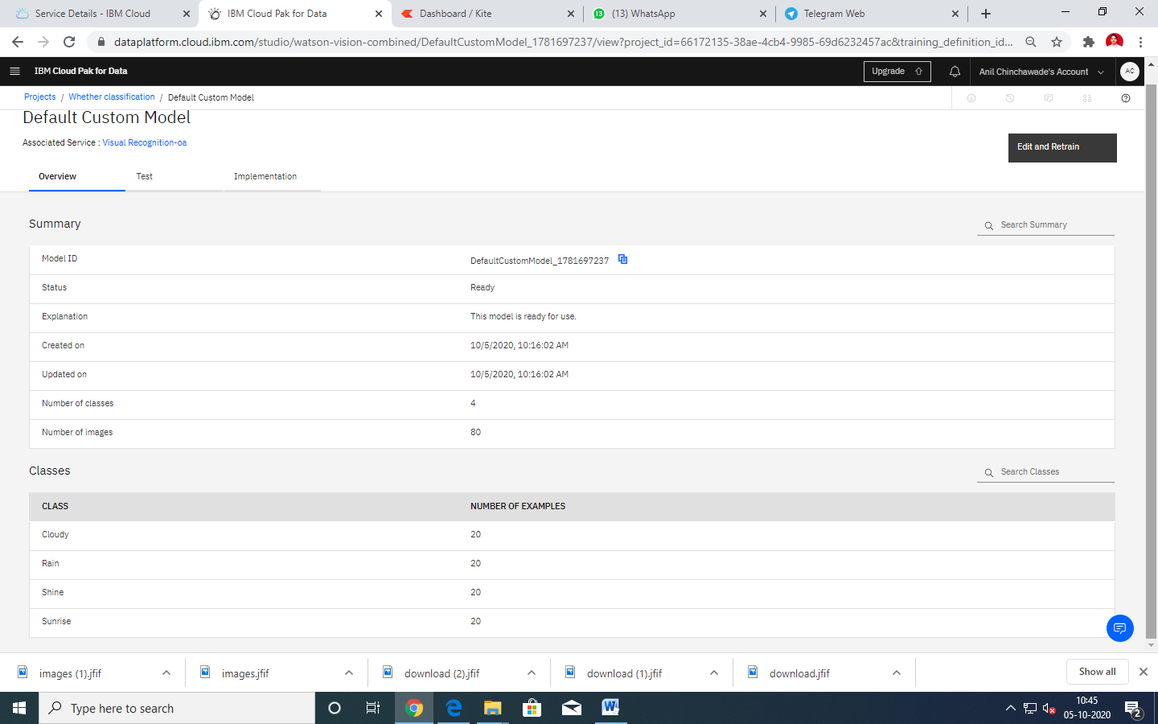

**FIG 2: Model Trained Successfully**

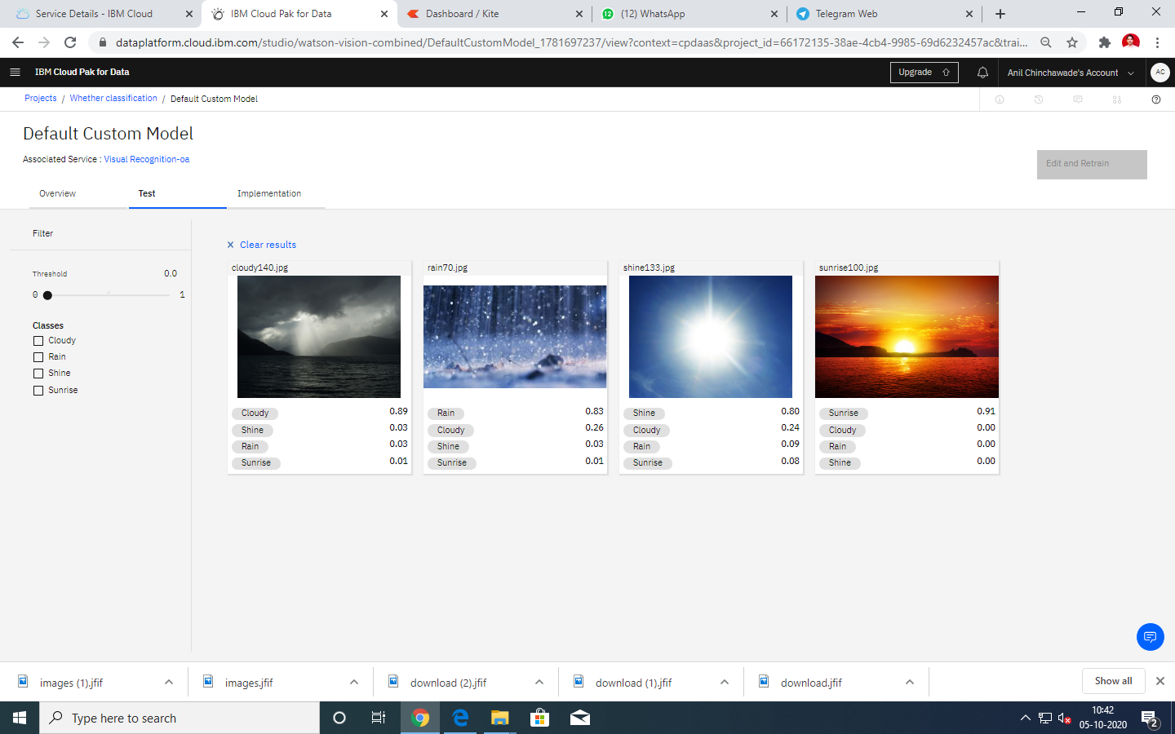

**FIG 3: Results Obtained**